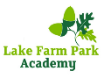
To question is to grow
Year 3 Autumn 2 Curriculum Map
‘Learning, Achieving, Aspiring Together’

Reading
Through our key text “Stig of the dump” by Clive King, pupils will be learning a range of reading skills including predicting, summarising, retrieving and inference. Pupils will have the opportunity to ask and answer questions whist immersing themselves in the adventures of Barney and Stig!
Writing
Pupils will be writing a diary entry and a set of instructions using the key text “Stig of the dump” as a guide. Pupils will be pretending to be Barney and will write their own diary entry based on Barney’s personal thoughts and feelings after meeting Stig for the first time. Pupils will also explore the different types of foods from Stone Age times and will create a Stone Age recipe using the features of an instruction text.
Overview: In Year 3 this half term, we will be learning about Stone Age, trying to answer questions related to the lifestyle during that period in prehistory. Pupils will develop researching skills, getting to investigate different types of rocks, learning to bake whole-wheat bread rolls, enquiring if Christmas has lost its true meaning and understand how to celebrate the differences between human beings. English lessons will be based on “Stig of the dump” by Clive King and the Maths focus will be addition and subtraction of 3 digit numbers.
Useful websites: Google Classroom www.nrich.maths.org www.mymaths.co.uk TTRS https://www.bbc.co.uk/bitesize

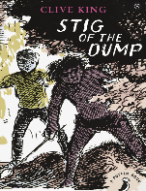

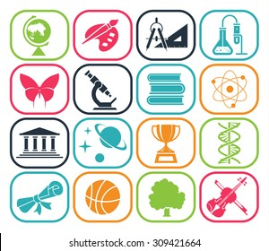  Geography  MDQ: What is the Stone Age?  Pupils will be tasked with locating continents and countries on the world map discussing about why humans travelled around throughout Ice Age period between Europe and Africa. They will be also identifying on the world map how humans have spread during Stone Age from Eastern Africa to Caucasus, Northern China, Indonesia and then Australia, Japan, Siberia. |   PSHE  Celebrating difference  Pupils will be exploring the different types of families; they will understand that conflicts can happen among family members and they will recognise that words can affect someone’s feelings. Pupils will also be learning about water safety, online safety and as a school we will be covering bullying during anti-bullying week. |   Music  This term, pupils will be identifying and performing various rhythmic patterns.  Pupils will also apply word chants to rhythms, understand how to link each syllable to one musical note and understand the differences between crotchets and paired quavers. The pupils will be creating effective rhythms, evaluate other children’s rhythms, perform rhythms accurately and play a rhythm as an ostinato.
History: MDQ: What is the Stone Age?  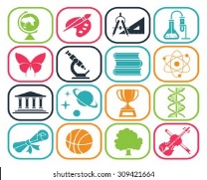  Pupils will be challenged to answer the main driver question as they learn about the three different periods of Stone Age, including researching about tools, houses, foods, clothes and jobs. Pupils will be also exploring the historians’ points of view related to the building of Stonehenge and its importance for us today. | Languages – French  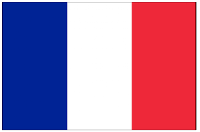  Introduction of France, its neighbouring countries, geographical location, capital, what is France famous for (monuments, food, wine, castles, TGV)  Numbers: 1-50 say and write  Colours: say and write  Days of the week - write  Greetings and self-introduction: writing  Making a passport using the self-introduction vocabulary. | Science  MDQ: What do I know about Rocks?  A series of investigations and experiments that will explain to pupils how different types of rocks are formed and what their unique properties are.  Our Enquiry Questions (EQ.) include:  What different types of rocks are there?  How can I describe the main groups of rocks?  Are all rocks waterproof and as hard as one another? How are fossils formed?
Religious Education  Religion: Christianity (Christmas)    Key Question: Has Christmas lost its true meaning? Pupils will find out what the true meaning of Christmas is to Christians and compare this with what Christmas means to other religions. | Art  Pupils will identify common images in the cave paintings and consider what they tell us about life in the Stone Age. Pupils will then get the chance to get creative with their own versions of prehistoric cave art. | 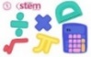  Maths  This term, we will be developing addition and subtraction of 3 digit numbers with and without exchanging. Pupils will be practising different calculation methods like partitioning, number line and column method. Pupils would then apply their arithmetic skills to one step/ multiple steps problem solving and reasoning questions
Physical Education - Hockey    This half term pupils will be focusing on hockey skills such as sending and receiving balls in a variety of situations, playing in small sided hockey-type invasion games, developing motor skills to handle sticks with ease and improve agility. | Computing - Animations    Pupils will be learning how to create animations; they will explore and recognise the issues with animations and they will make changes to ensure their smooth running. | Design Technology  Pupils will make thoughtful observations and will be designing and making their own Stone Age jewelleries using salt dough and paint.    Food technology: Whole wheat bread rolls.

